**Assessment of refrigeration load for a solar cold storage system in Aligarh, Uttar Pradesh**

Harendra Singh

Roll no - 234107007

M-Tech: Chemical Engineering Department

Indian institute of technology Guwahati

**ABSTRACT**

India, the world's second-largest producer of fruits and vegetables, faces significant post-harvest losses, with up to 16% wastage due to a lack of processing facilities. The scarcity of cold storage, especially in rural areas with unreliable power, contributes to economic losses. Solar-powered cold storage offers a promising solution, and in Assam's Kamrup district, a 10 MT capacity system could be sustained by 120 square meters of solar collectors, reducing post-harvest losses. This study emphasizes the potential of solar energy in addressing agricultural challenges.

**INTRODUCTION**

A Vapor Absorption Refrigeration System (VARS) is a type of refrigeration system which uses solar energy, a low-grade energy, as input source and runs on the thermodynamics cycle as shown in Fig1. The various components viz. generator, condenser, evaporator, absorber, expansion devices, solution heat exchanger and solution pump is shown in the figure. The system takes solar energy as input in generator through collector and gives a refrigerated effect in evaporator as an output .

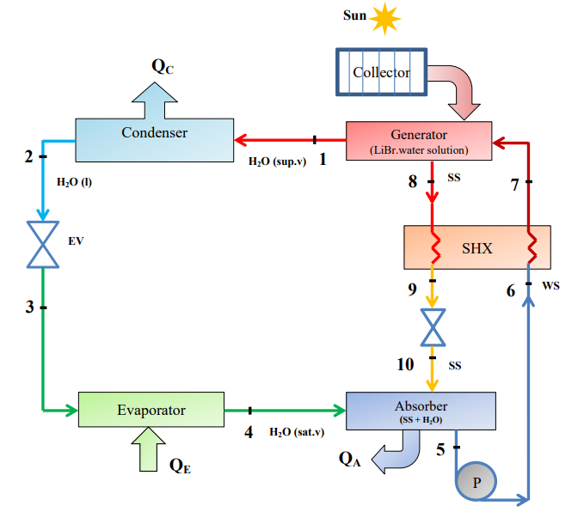

**Fig.1** Schematic of a Solar refrigeration system based on VAR cycle with a collector.

**METHODOLOGY AND CALCULATIONS**

For designing a solar VARS the assessment of evaporative (refrigeration) load is primary objective for a selected area. Guwahati( Assam) is selected for designing the cold storage system of 10MT capacity. For the calculations of various loads temperature and humidity data is collected for the year 2022 and the calculations of total refrigeration load , solar collector area are performed on the basis standard equation s of heat transfer as shown below

The variations of relative humidity and temperature for the year 2022 are shown in fig2

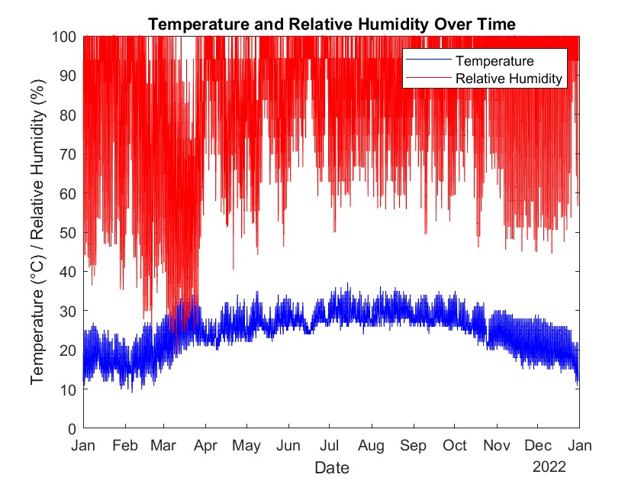

**Fig. 2** Monthly variations of humidity and temperature for Guwahati, Assam (2022).

After selection of a particular site, the following steps as shown below, has been taken to calculate the demand load for the SVARS-

The commodity selected for load calculation is potato and the optimum storage condition are given below

Critical Temperature( Tc) -10 $℃$

Humidity (%) - 90-95

Specific Heat capacity Cp(kJ/kg) - 3.43

Cold room dimensions as per National Horticulture board (NHB) for 10MT are considered as follow and a cross of a wall is also shown in Fig3.

Storage Dimensions = 4.26(L) $×$ 3.04(W) $×$ 3.04(H) m3

Total wall area = 44.38m2

Total roof area = 12.95m2

Chamber’s Volume = 39.37 m3

The segments of total refrigeration load are:

• Transmission Load,Q1, which is heat transferred into the refrigerated space through its surface

• Product Load,Q2, which is heat removed from and produced by products brought into and kept in the refrigerated space

• Internal Load,Q3, which is heat produced by internal sources (e.g., lights, electric motors, and people working in the space)

• Infiltration Air Load,Q4, which is heat gain associated with air entering the refrigerated space

• Respiration Load Q5, which the heat generated by the product due to respiration.

The different load can be calculated by the following thermodynamics principle-

**Transmission LoadQ1 (Fig.4)**

The building transmission load is the total amount of heat that leaks through the walls, windows, ceiling, and floor of the refrigerated room per unit of time (usually kW or kJ/s). Heat leakage, therefore, is affected by the amount of the exposed surface, thickness and the kind of insulation used, and the temperature difference between the inside and the outside of the refrigerated room . Thus, it is the heat transfer from the outside into the refrigerating space via the insulated walls of the refrigerator: and is given by-

**Q1 = UA∆t (1)**

**Where, U = $\frac{1}{\frac{1}{hi}+\sum{\left(\frac{xi}{ki}\right)+\frac{1}{h0}}}$ (2)**

where

U = Overall heat transfer coefficient (W/m2K)

∆t = temperature difference between inside and outside of the wall or roof of cold room ( $℃$)

A = area of the wall or roof (m2 )

xi = wall thickness, mm (a wall cross section shown in Fig.3)

ki = thermal conductivity of wall material (W/mK)

hi = inside heat transfer coefficient. (W/m2K)

ho = outside heat transfer coefficient. (W/m2K)

Now, Overall Heat transfer coefficient for wall and roof of cold room can be calculated as-

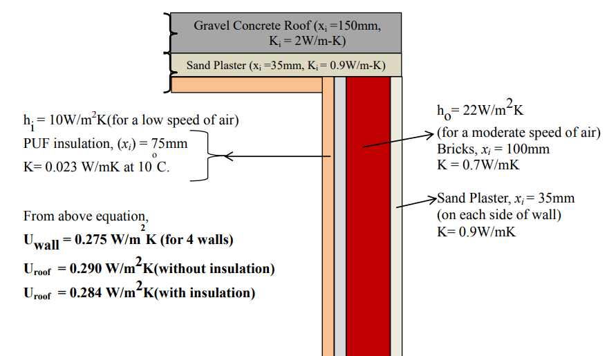

**Fig.3**

**Infiltration Load Q2 (Fig.5)**

Air that enters a refrigerated space must be cooled. Air needs to be renewed, and consequently there is a need for ventilation. When air enters the refrigerated space, heat must be removed from it. Air which enters the refrigerated space usually cools and reduces in pressure. If the refrigerated room is not airtight, air will continue to leak in. Also, each time a service door or walk-in door is opened, the cold air inside, being heavier, will spill out the bottom of the opening, allowing the warmer room air to move into the refrigerated room. The actions of moving materials in or out of the refrigerated room, and a person going into or leaving the refrigerated room, result in warm air moving into the refrigerated space through the process of air infiltration . Hence, the air change heat load is the heat transfer due to closing and opening of the refrigerator doors and subsequent changes in the air-heat content in the refrigerated space. It is given by the following equation.

**Q2 = ρair Ac Vc Δh (3)**

Where,

ρair = air density(1.225 kg/m3 )

Ac = Air change rate (4 per day for a 50 m 3 size room).

Vc = room volume (m3 )

Δh = (ho - hi) = change in enthalpy = Total Heat Removed to Cool Storage Room Air (kJ/kg).

Change in enthalpy = 1.005*(Tdb-Tinside) +(Wair -Winside)*2500  
Tdb= dry bulb temperature of air.

Wair = specific humidity of air.

Wair is calculated from the relative humidity( extracted from the data)

Relative humidity =Pv/Pvs  
Wair= .622*Pv/(Pt-Pv)

Pvs=saturation pressure of water vapour(assumed 101.325 kpa)

Pv=Partial pressure of water vapour

**Internal Load Q3**

Calculation of Internal load

Due to fans, assuming 2 fans of 0.75kW of each = 1.5kW

Lightning load, (assuming at 10W/m2 during loading),

Lightning load = (Floor area x 10) W = 12.95x10 = 129.5W = 0.1295kW

Occupancy Load (Assuming 3 persons working inside contributing 250W each)

Occupancy Load = 3 x 250 = 750W = 0.75kW

Total Internal Load (Q3)= 1.5 + 0.1295 + 0.75 = 2.3795kW

**Respiration Load Q4**

Heat of respiration is released during this exothermic reaction, which adds to the refrigeration load during cooling of fruits and vegetables. The rate of respiration varies strongly with temperature and at t $℃$, can be calculated from the reference [1] .

**Q4 = 0 .450 KW ( For potato)**

**Product loadQ5 (Fig.6)**

Any substance that is warmer than the refrigerator is placed where it will lose heat until it cools to refrigerator temperature. Respiration heat is the heat given off by living things, especially plant products, in this case potatoes. The product heat load is given by-

**Q5 = mCp(ta – tc) (4)**

and Average Product Load**, q = Q5 /(3600n) (5)**

where

Q5 = Product load (kJ)

q = Average product load (kW)

n = no of hours

m = 10MT (mass of the commodity)

tc = Cooling Storage Temperature in Degree Celsius

ta = Ambient Temperature in degree Celsius

Cp = Specific Heat Capacity in kJ/kg-Celsius

**Safety factor**

Load due to condensation and freezing of moisture on cooling coil is very less and can be neglected by considering a safety factor. Generally, the calculated load is increased by a factor of 10% to allow for possible discrepancies between the design criteria and actual operation.

Total Refrigeration Load, (with safety factor of 10%) is calculated as follows is shown in fig7:

**Qt = (Q1 + Q2 + Q3 + Q4 + Q5)*(1+safetyfactor/100) (6)**

**Collector Area**

The collector is a type of solar thermal heat exchanger that has main objective is to absorb solar energy which is used to raise the temperature of generator solution mixture (LiBr.Water solution). Therefore, the temperature of the collector is as high as boiling point of water so that it can be able to vaporize the water in generator, otherwise the VAR system will not operate well. Hence an optimum area of collector having a high conductivity collector material is required to do so. The calculation for this area has been done through the following equation of COP in which the COP of the system and efficiency of the collector is considered 0.7 and 0.5 respectively.

**COP = $\frac{QE}{Ac.I.η}$ or Ac = $\frac{QE}{COP.I.η}$**

Where

QE = Area under the total refrigeration load curve

Ac = Collector Area (m2 )

$η$ = efficiency of the collector

COP = Coefficient of performance of VAR system

I = Average solar Irradiation (5 kWh/m2 per day)

**Result**

Energy required to run the cold storage for the whole year: 87205.167411 kWhr

Total energy to be generated by solar to run the cold storage for whole year : 124578.810588 KWhr

Area required for installing solar collector for 10 MT cold storage is 195.035320 sq.m

The maximum value of refrigeration load during the year 2022 is 10.9701 K [1]W.

**Fig.4**

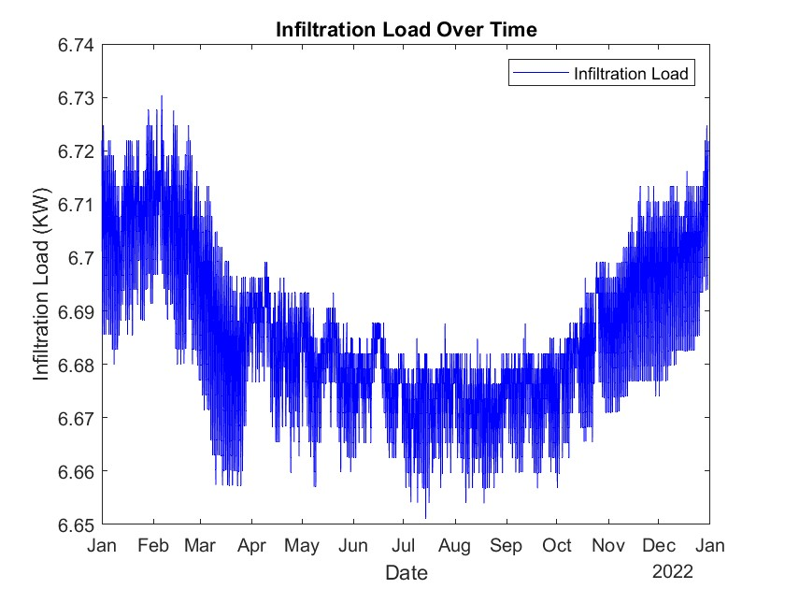

**Fig.5**

**Fig.6**

**Fig.7**

**Reference**

|  |  |
| --- | --- |
| [1] | A. K. S. D. K. B. Gopal Tripathi, “Assessment of refrigeration load for a solar cold storage system in Guwahati,Assam,” Assam, 21 dec 2020. |